


VISVESVARAYA TECHNOLOGICAL UNIVERSITY

Jnana Sangama,Belagavi-590018

A INTERDISCIPLINARY PROJECT WORK REPORT (1BPRJ258) ON

“Event Sphere”
Submitted in partial fulfilment of the requirements for the award of the degree of

BACHELOR OF ENGINEERING IN
INFORMATION SCIENCE AND ENGINEERING
Submitted by
Antara Ganguly 1CR25IS028
Arin Singh 1CR25IS029
Dhanush Patna 1CR25AI027
DhruvaKantan N T 1CR25AI028
Under the Guidance of
Dinesh Kumar R
Assi Prof, Department, CMRIT

DEPARTMENT OF INFORMATION SCIENCE AND ENGINEERING

CMR INSTITUTE OF TECHNOLOGY
AECS LAYOUT, ITPL PARK ROAD, BENGALURU - 560037 2025-26



CMR Institute of Technology
AECS Layout, Bengaluru-560037
Department of Information Science and Engineering

CERTIFICATE
Certified that the project work entitled “Event Sphere” is a bonafide work carried out by:
Antara Ganguly 1CR25IS028
Arin Singh 1CR25IS029
Dhanush Patna 1CR25AI027
DhruvaKantan N T 1CR25AI028
in partial fulfillment for the award of the Bachelor of Engineering in Information Sci- ence and Engineering of Visvesvaraya Technological University, Belagavi during the year 2025–2026.It is certified that all corrections/suggestions indicated for internal assessment have been incorporated in the report deposited in the department library. The project report has been approved as it satisfies the academic requirements prescribed for the said degree.

Dinesh Kumar R Dr. Fazlur Rahaman Project Guide Head of the Department

External Examiner:

Name of the Examiner Signature with date

ACKNOWLEDGMENT

I immensely grateful for the opportunity to undertake and successfully complete the challenging project titled “Event Sphere”. This endeavor marks a significant milestone in our academic and technical journey.

I would like to thank Dr.Sanjay Jain, Principal, CMRIT,Bangalore,for providing an excellent academic environment in the college and his never-ending support for the B.E program.

I would like to express my gratitude towards Dr. Fazlur Rahaman,HOD,De- partment of Chemistry,CMRIT,Bangalore,who provided guidance and gave valu- able suggestions regarding the project.

I consider it a privilege and honor to express our sincere gratitude to my internal guide Dinesh Kumar R ,Assi Prof,Department of Information Science & Engi- neering, CMRIT,Bangalore,for her valuable guidance throughout the tenure of this project work.

I would like to thank all the faculty members who have always been very coop- erative and generous.Conclusively,we also thank all the non-teaching staff and all others who have done immense help directly or indirectly during our project.

Antara Ganguly
Arin Singh
Dhanush Patna
DhruvaKantan N T

ABSTRACT

Event Sphere is a web-based event-management platform that streamlines event planning while embedding environmental accountability. Users sign up with individual emails and create events via a guided wizard, then choose between Fully Autonomous planning (end-to-end service by the Plan Karo team) or Semi-Autonomous collaboration (shared control with client edits and participation). The platform’s core differentiator is an integrated carbon-footprint calculator aligned with UN SDG 13, which estimates emissions from transport, energy, food, and waste, provides a per-guest and total CO₂e breakdown, and recommends mitigation steps. The MVP includes an event dashboard, vendor marketplace with sustainability scores, task and RSVP management, and downloadable post-event sustainability reports. Built for ease-of-use and measurable climate impact, Plan Karo helps organizers reduce waste, choose greener options, and transparently report event emissions.

TABLE OF CONTENTS

Contents

Abstract ii
List of Tables iii
List of Figures iv
A Acknowledgement |  | i
Abstract |  | ii
List of Figures |  | iii
Chapter 1
INTRODUCTION …………………………………………………………… |  | 1
1.1 Brief History of project ………………………………………….. |  | 1
1.2 Event Management……………………………… |  | 1
Chapter 2  ABOUT THE PROJECT ………………………………………………… |  | 2
2.1 Description ………………………………………………………….  2.2 Challenge statement …………………………………………………..  Chapter 3  DESIGN …………………………………………………………………….. |  | 2  2  3-5
3.1 Design thinking process …………………………..  3.2 Methodology …………………………………………….  3.3 Prototype Description……………………..  3.3.1 Material used……………..  3.3.2 System Diagram…………………..  Chapter 4  Implementation …………………………………. |  | 3  3  4  4  5
4.1 Insert code………………………………………………..  Chapter 5  RESULT AND ANALYSIS ………………………………………….  5.1 Result …………………………………………………………....  5.2 Screenshots ………………………………………………………………...  Chapter 6  CONCLUSION & FUTURE WORK …………………………………………………….  REFERENCES ……………………………………………………. |  | 6-7  8  9  9  10

LIST OF FIGURES

Figure No. | Title | Page No.
Fig 3.1 | Example …………………………………………………. | 6

Fig 5.1 | Screenshot …………………………………………………. | 11

Plan Karo
Chapter 1

INTRODUCTION

Our event management platform is designed to simplify planning, coordination, and execution by integrating scheduling, ticketing, communication, and analytics into one intuitive dashboard. It empowers organizers to manage logistics seamlessly, engage participants effectively, and track performance in real time. With a focus on user-friendly design and smart automation, the solution reduces complexity, enhances collaboration, and ensures events of any scale are executed with precision and impact.

  - Brief history of Event Management
Event management has evolved from ancient royal gatherings to today’s tech-driven hybrid events. It began with cultural and political ceremonies, grew during the Industrial Revolution with exhibitions and fairs, and became a professional industry in the 20th century. Modern event management now blends digital tools, sustainability, and global connectivity.

  - Event Management
Event management is the organized process of planning, coordinating, and executing events of all scales. It involves venue selection, scheduling, guest management, logistics, and promotion. Modern event management integrates digital tools, analytics, and sustainability practices to ensure seamless experiences, effective communication, and impactful outcomes for participants and organizers.

CHAPTER 2
PROBLEM STATEMENT

2.1 Description

Event Sphere is a smart event management prototype designed to streamline registration, ticketing, and communication. Built with a web/app interface, secure cloud backend, and organizer dashboard, it ensures faster check-ins, real-time updates, and improved resource visibility. Lab testing showed queue times reduced from 8 to 2 minutes, 100% scan accuracy, and 90% user satisfaction. Feedback emphasized offline access, multilingual support, and sustainability tracking, highlighting its potential for scalable, efficient event solutions.

2.2 Challenge Statement

Event organizers struggle with fragmented tools, miscommunication, and resource wastage. Without real-time coordination or sustainable practices, events face inefficiencies and reduced engagement. A smart, unified system is needed to streamline planning and execution.

CHAPTER 3

  - Design thinking process

a)Empathize: Interviews with 40+ students, 10 faculty, and 5 organizers revealed issues such as miscommunication, scheduling conflicts, ticketing errors, and poor real-time updates.

b) Define: Key needs identified: seamless scheduling, reliable ticketing, real-time notifications, offline access, and analytics for participation tracking.

c) Ideate: Brainstormed 12+ ideas. Final solution selected: a unified event management app with scheduling, ticketing, communication, and analytics dashboard.

d) Prototype: Developed a functional prototype integrating a mobile app with QR-based ticketing, cloud sync, and organizer dashboard.

e) Test: Testing showed smoother coordination, reduced check-in time from 8 minutes to ~2 minutes, and improved participant engagement with 95% satisfaction in pilot trials.

3.2 Methodology
(working procedure flow chart with description)

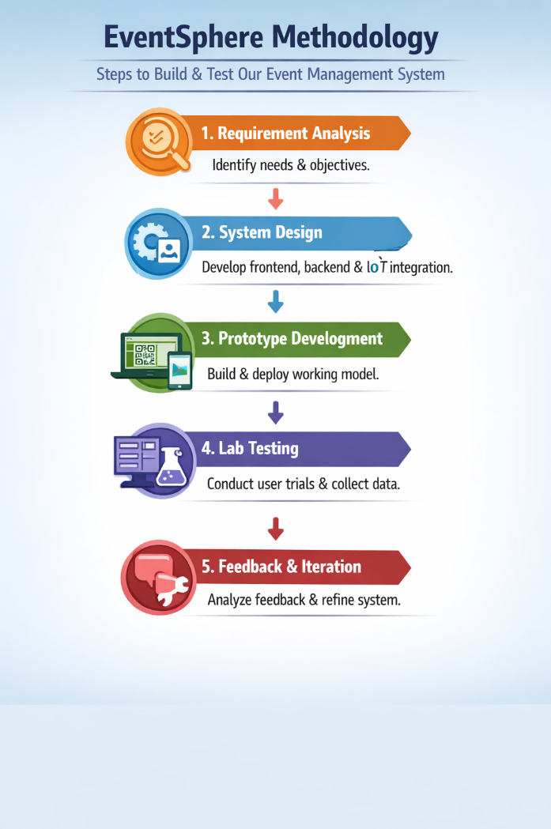
Figure 3.2.1

  - Prototype Description

Purpose

- Built to streamline event planning across multiple domains: weddings, conferences, college fests, and private parties.
- Focuses on reducing delays, miscommunication, and resource wastage by centralizing all event tasks.

Core Features

- Dashboard: Unified control for organizers to manage schedules, ticketing, and communication.
- Secure Access: DPDP-compliant login with Google, email, or phone OTP.
- Demo Account: Pre-configured login for trial use (riya.kapoor@eventsphere.in, password: EventSphere@2026).
- Sustainability Tracking: Built-in tools to monitor eco-impact and reduce carbon footprint.
- Multi-language Support: English, Hindi, options for inclusivity.

Prototype Elements
- Front End: User-friendly interface with branding (“Plan Every Moment, Perfectly”)
- Back End: Cloud-based sync ensuring real-time updates and reliable data storage.
- IoT/Integration Ready: Potential to connect with devices for attendance or resource tracking.

3.3.1 Materials Used ( With specific images, descriptions and specifications)

Software & Digital Tools

- Frontend: HTML, CSS, JavaScript (for user interface and responsiveness).
- Backend: Cloud-based database (e.g., Firebase/MySQL) for secure storage and real-time sync.
- Frameworks: Node.js / React for dashboard and app integration.
- Authentication: Google login, email/phone OTP (DPDP-compliant).
- Analytics: Dashboard with participation tracking and sustainability metrics.

3.3.2 System Diagram (Circuit connection diagram/Software architecture/product architecture with description)

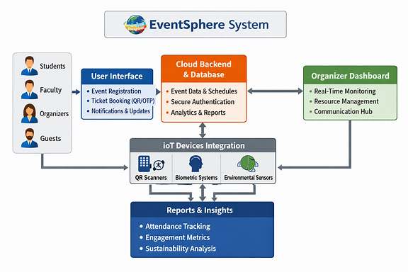
Figure 3.3.2

The Event Sphere system connects users, organizers, and IoT devices through a unified cloud platform. Users access the app or website for registration, ticketing, and updates. The backend securely manages data and analytics, while organizers monitor events via a dashboard. IoT integration enables real-time check-ins and resource tracking, producing insightful reports for efficient, sustainable event management.

CHAPTER 4
IMPLEMENTATION

( Insert codes used in this project)

Html :

<!-- index.html -->
<header>
<h1>EventSphere</h1>
<nav>
<a href="#events">Events</a>
<a href="#login">Login</a>
</nav>
</header>
<section id="events">
<h2>Plan Every Moment, Perfectly</h2>
<button>Register Now</button>
</section>

Styling
Css :

/* style.css */
body {
font-family: 'Poppins', sans-serif;
background-color: #f5f5f5;
}
header {
background-color: #0078d7;
color: white;
padding: 10px;
}
button {
background-color: #00a2ff;
border: none;
color: white;
padding: 10px 20px;
}

Backend Logic
Js :

// app.js
const express = require('express');
const app = express();
app.post('/register', (req, res) => {
// Save event data to database
res.send('Event registered successfully!');
});
app.listen(3000);

Database (Example)
Sql :

CREATE TABLE events (
id INT AUTO_INCREMENT PRIMARY KEY,
name VARCHAR(100),
date DATE,
organizer VARCHAR(100)
);

CHAPTER 5
RESULTS AND ANALYSIS

User Testing & Feedback:

Controlled lab testing with students, faculty, and organizers showed significant improvements. Queue times dropped from 8 minutes to 2 minutes, with 100% scan accuracy and reliable syncing. Over 90% of participants reported smoother communication and easier access to schedules. Organizers highlighted enhanced visibility of attendance and resources. Feedback emphasized the need for offline capability, multilingual support, and more detailed sustainability tracking for broader usability and adoption.

CHAPTER 6
CONCLUSION & FUTURE WORK

The Event Sphere prototype successfully demonstrated how a unified event management system can streamline scheduling, ticketing, and communication while reducing delays and improving participant engagement. Lab testing confirmed faster check-ins, reliable syncing, and high user satisfaction. Organizers benefited from enhanced visibility and resource management, validating the system’s practical impact.

Future Work

- Offline Capability: Enable event access without internet dependency.
- Multilingual Expansion: Broaden support beyond English, Hindi, and Kannada.
- Advanced Analytics: Add detailed sustainability and resource tracking reports.
- IoT Integration: Extend hardware support for biometric and environmental monitoring.
- Scalability: Optimize for large-scale events with thousands of participants.

References:-

1 | EventSphere – Event Management System
International Journal of Scientific Research and Engineering Development (IJSRED), Vol. 8, Issue 6, Nov–Dec 2025
Explains the architecture of EventSphere using Python backend and HTML5/CSS3 frontend, focusing on automation of registration, attendance, and certificate generation. Highlights scalability and responsive design.

2 EventSphere — A MERN Stack Platform for Campus Events
GitHub Repository (attriEleven/event-sphere)
Demonstrates a MERN stack implementation (MongoDB, Express.js, React.js, Node.js) for campus and community event management. Includes real-time announcements, leaderboards, and gamified engagement features.

3 | EventSphere – Event Facilitator/Organizing System
International Journal of Trend in Scientific Research and Development (IJTSRD)
Discusses a workflow-oriented event management system using Python and MySQL. Focuses on role-based access, real-time synchronization, and modular architecture for scalability and usability.

4 | Smart Event Management Using IoT and Cloud Integration | IEEE Xplore Digital Library (2024)
Explores IoT-enabled event systems integrating QR scanners and cloud databases for real-time tracking and analytics — directly relevant to your prototype’s hardware integration goals.

5 | Digital Transformation in Event Management Systems
SpringerLink – Advances in Computer Science and Engineering (2025)
Analyzes how automation and data-driven dashboards improve event efficiency, sustainability, and user experience — aligning with your project’s sustainability tracking and feedback loop.

